Welcome to the Little Swan Lake website. The lake is located 4 miles west of Avon, Illinois. Little Swan Lake is a private lake made up of members who either own or lease property and are represented by the Little Swan Lake Club Board who are elected by the members.
We welcome new people to our Committees. Check out the volunteer opportunites by clicking on: volunteers. If a member is interested in working on one of the committees, please contact the committee chair or any board member. Board Meetings are held the first Monday of the month at 7 PM.
There is a director position open at the Little Swan Lake Sanitary District Board of Directors. For more information.
The LSL Board, following State law, has removed most of the tires from the lake. Tires can no longer be used in the lake. It is our intent to leave poles that are in good shape and upright in the lake. But those that are a hazard or obstructing access will be pulled. Poles that are reusable will be stockpiled at the outlot. Poles that are too bent or rusted to reuse will be recycled.
An idea that could be used instead of tires are PVC pipes that can be slid over the metal poles and will not damage the boat.
Check out construction photos of the new Boat Ramp. The ramp is now complete and can be used even though the lake is down several inches.
Annual Meeting results: Bob Andersen, Alan Jonckheere, Russ Morgan, Duane Taflinger and Danny Mahr were all elected to the LSL Board. The Bylaw change was approved while the Siltation fee, the Maintenance fee and the new ski boat classification were defeated. For those who did not attend you can read the Annual Meeting PowerPoint .
The County is looking for Election judges. Check out the

Siltation Committee News:
Letter from the Warren County Soil and Water Conservation District (SWCD) and the local Natural Resource Conservation Service. Cathy Olson, District Conservationist, will hold 2 meetings to discuss concerns of sedimentation coming into the lake.
Click on Siltation Committee on the left menu for more information.
-->

Read the most recent Little Swan Lake Newsletter. You may also click on the News menu option.

We have a new Ladies of the Lake newsletter. You may also click on the Ladies of the Lake(Monthly News) menu option.

Fish were stocked in October 2017 with 75 Northern Pike, and 435 Walleye.
Swans spotted on the lake - February 3, 2017
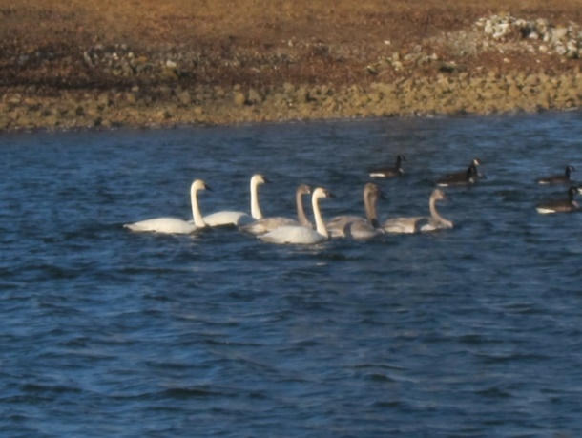

Guest-Owner Reponsibilites
As stated in the Little Swan Lake Club (LSL) Covenants, it is the responsibility of the Little Swan Lake Member to make sure that guests are aware of and abide by all the rules and regulations of Little Swan Lake as well as state and local laws and regulations. The LSL rules are posted on our web site http://littleswanlake.net. Below are a few requirements of special note for guests to use the LSL facilities, including the lake. Most of these are listed also in the various specific sections with more detail, but are gathered here for convenience.
  - ■ Clubhouse: the LSL member reserving the clubhouse must be present during the event.
  - ■ Fishing: a LSL member must be present when a guest is fishing either in a boat or on the shoreline, unless the shoreline is the member’s property. The fisher must be properly licensed by the State of Illinois in all cases.
  - ■ Boating: a LSL member must be present at the lake when a guest is using the member’s motorized boat. No guest boats are allowed.
  - ■ Other sport use: a LSL member must accompany the guest when snowmobiles, 4-wheelers etc. are used on any LSL property, including the lake. No vehicles are allowed on the dam without express permission of the LSL board.
  - ■ Swimming: It is fine for guests to swim no further than 100 feet from shore off a member’s property with no member present. There is no swimming off boats in the Wake Zone or off outlots. When swimming off a member’s boat in the no-wake zone a member must be present at the lake.

SWIMMING RULES IN THE NO WAKE ZONE
  - ■ Boats must be anchored and motor turned off
  - ■ Boats must stay in the center of the no wake zone not in the traffic lanes
  - ■ Swimming will only be allowed from 30 minutes before sunrise until 30 minutes after sunset. Note: if you are swimming within 100' of your own shoreline property there are no hour restrictions.
  - ■ Swimmers must stay within 30’ of the boat
  - ■ A responsible person, 18 years or older must stay in the boat
  - ■ NO DIVING allowed
  - Be sure to inform anyone in your boat of these rules. BE SMART - BE SAFE!
Rules will be strictly enforced with a minimum fine of $25 for the first offense and repeated offenses could lead to loss of lake privileges.

IMPORTANT BOATING REMINDERS
Tubing or Skiing - There is a new law which requires a flag flying at the highest part of your boat while pulling tubers or skiers or when they are in the water. While skiing or tubing, be sure to have a responsible spotter, the driver cannot be considered a spotter. Boat in a counter-clock-wise pattern. Children under 13 must wear life preservers. Lights must be used after dark and boats are restricted to a no-wake speed after dark..
Boat Ramp Parking – Please be sure boat trailers are parked at the ramp area rather that at the Clubhouse. The Clubhouse is often reserved for other functions and the parking spaces are needed. One or two trailers can take up a lot of parking spots. We realize at times additional trailer parking could be used and we are considering options in the Long Range Planning Committee. Anyone interested in working on the project, please contact a Board Member.

Rules and Regulations
December 2015
The Committee on Rules and Regualtions has reviewed the current rules and has made several recommendations to the membership. These changes include removing duplicate or redundant information, making it readable by using common language, and updating incorrect information and rules.

Membership & Boating Forms
November 2017
The membership and boating forms will be sent out in January. If you have not received the documents or are new to Little Swan Lake, you may download the forms on our forms page or please send an email with your request to Barb Dunlap (LSLClerk@hotmail.com) or call 309-465-6734.

Recycling Information
January 2016
Recycling Drop-Off

Items Accepted:
Newspaper
Magazines
Cardboard, Cereal & Kleenex boxes
Office Paper, Junk Mail
Telephone Books
Hardback & Paperback Books
Aluminum Cans & Foil
Aluminum Scrap (lawn chairs, siding)
Steel or Tin Cans
Light Steel (coat hangers, bicycles, etc….)
Plastics #1 – 7, except #6 - (look for the number inside the recycling triangle)
Bags of Plastic Grocery Bags (#2 or #4), Bubble Wrap

Containers must be free of food waste!

Not Accepted:
Glass
Styrofoam (#6)
Wax Cardboard (milk and juice cartons)
Construction Paper
Paper Towels & Kleenex
Paint
Electronic Equipment
White Goods (washer, dryer, stove, etc.)
Household Garbage
Plastic Toys

Search

